
Naval
Postgraduate
School
Monterey, California

U2 – UGV Embedded Software Transition Planning with iRobot + ROS
Architecture and Module/Class Design
December 2025

Prepared for: SE 4003: Systems Software Engineering (FA26_51_HM)

State Diagram
To help understand the system before describing the Architecture, we drafted an operational state diagram to illustrate and test to ensure our system operates as intended.
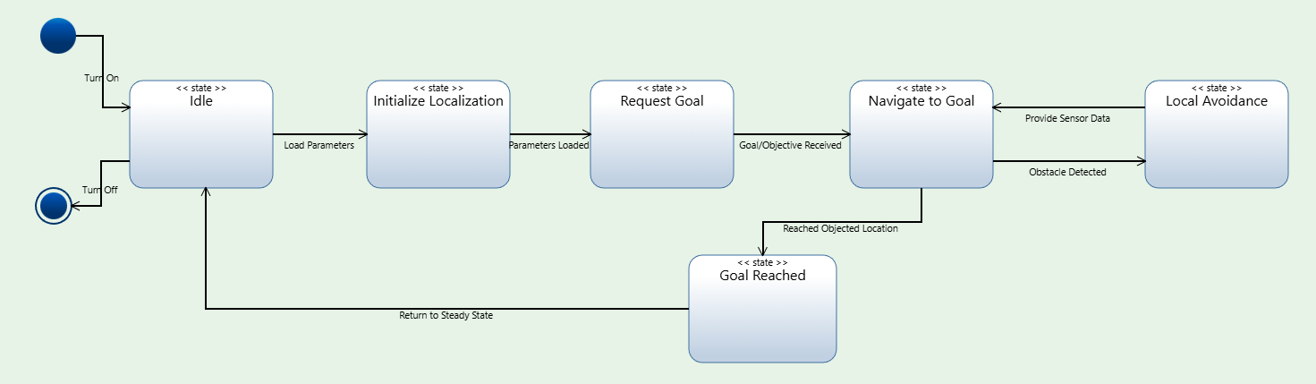
Figure 1: State Diagram
In Figure 1, we have the system either be in a Starting or ending state. To avoid overcomplexity much of the functionality is off-shored to the Baystation which would command the robot and store historical maps where the robot as seen in figure 1 would be focused on navigating and course correction. Some functionality that is not seen at this level of the state diagram are fault detections and map updates. These are mentioned briefly but to avoid overcomplications are not gone in depth at this iteration.

Package Diagram
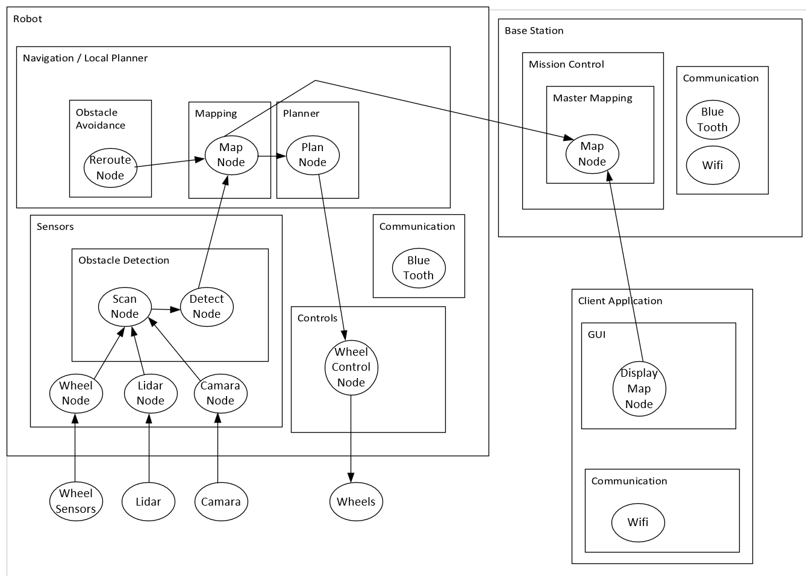
Figure 2: Package Diagram
We decided to generate a Package diagram to help simplify the class diagram that we will be showing in figure 3. From the State Diagram, we are primarily focused on the Robot which would be containing the Navigation, Sensors, Control, and communication classes. The Baystation and Client Application are not described in this document at this time as the primary classes are found in the Robot class. Each Arrow depicts dependency.
The items below the robot are hardware components the system interacts with.

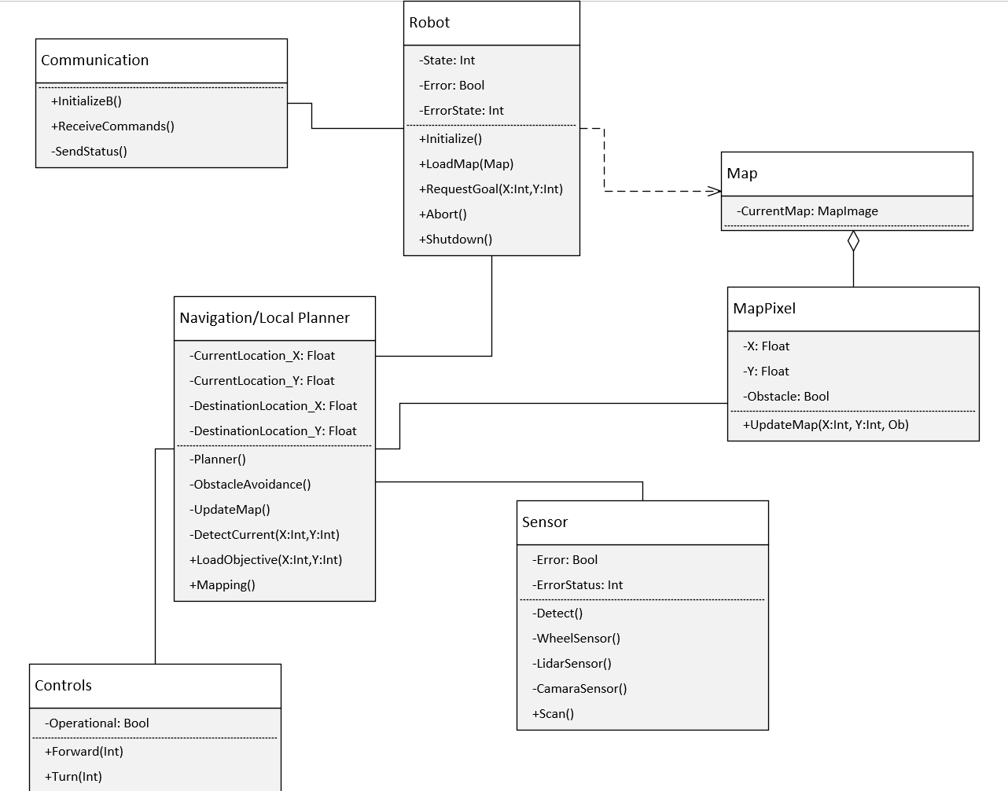
Figure 3: Class Diagram
As described before, the class diagram in Figure 3 describes the inner workings of the system.
Communications Class
Overall Function: External Interface with the Baystation
Functions:
- Initialization(): Wake up the Robot and put it into Idle Mode for commands
- ReceiveCommands(): Receive XML string for executing particular function calls. Primarily calling the Robot calls such as Load Map, Request Goals, Abort, and Shutdown. It also may pass the working copy of the map found on the bay station.
- SendStatus(): This is a function that the robot class may call to give status updates as well as error codes encountered by the robot upon mission

Robot Class
Overall Function: The Main class of the system
Attributes:
- State: Int – This is an internal attribute tracking the current state of the system
- Error: Bool – This is an internal attribute that flags the system is currently in an error state
- ErrorState: Int – This is an internal attribute that tracks if the error had occurred what is the returned exact error code to pass back to the baystation.
Functions:
- Initialization(): This is the initialization of the robot. While the communication may issue the command, this performs the necessary self diagnosis of the system to validate the system is in a working state.
- LoadMap(Map): This function loads the map that it was passed. If no map is passed, then it would create a new instance of the Map value. In this case, the system will navigate to create a map of the environment till either the map is complete or the system experiences an error.
- RequestGoal(X,Y): This function is executed to indicate to the robot that a goal is required to be reached per the Baystation.
- Abort(): This function allows the robot to stop and go into an Idle state until another command is issued.
- Shutdown(): This function is to put the robot into a hibernation state. Only to be reactivated when it receives the communication request to turn on.

Map Class
Overall Function: This class is more of a variable “Map” where the pixelated representation of the map is generated or captured. The Map focuses always as the bay station as 0,0 and the constraint of the system is a positive and negative long int (+/- 2,147,483,648) coordinates.
Attributes:
- CurrentMap: MapImage – This is the image as described above
Functions:
- Initialize(MapImage) – this function loads the map image if exists into the class

MapPixel Class
Overall Function: This class is the pixel found in each MapImage. Overall each coordinated is indicated if it is a free or if its an obstacle. This is called in order to update new data from external systems.
Attributes:
- X: Int – This is the coordinate reflected on the pixel. X indicates either positive or negative X coordinate based on the base station orientation.
- Y: Int – This is the coordinate reflected on the pixel. Y indicates either positive or negative Y coordinate based on the base station orientation.
- Obstacle: Bool – This indicates if the position is an obstacle or not.
Functions:
- UpdateMap(X,Y,Ob) – This is a function to update the map

Navigation/Local Planner Class
Overall Function: This Class is the main execution of the system. While the main mission is controlled and operated from the baystation, this provides the main functionality of the robot purpose
Attributes:
- CurrentLocation X/Y: Int – Tracks the current location of the robot
- DestinationLocation X/Y: Int – Tracks the desired location of the robot per mission directives.
Functions:
- DetectCurrent(X,Y) - This function attempts to reorient itself based on the communication strength of the baystation and the data it collects from the sensors (camara and laser optics). It would attempt to determine its location. This is particularly important after an error had occurred and it is attempting to course correct to avoid mapping errors.
- Planner() - Based on the current map the planner issues commands to the controls to move in particular location.
- ObstacleAvoidance() - This function will attempt to course correct if it encounter an obstacle. The internal logic would rely on the sensors to reroute to avoid the obstacle it found.
- UpdateMap()- This function based on either unmapped locations or obstacles detected would update the map with the obstacles identified. It would update its local copy and allow the Bay station to determine if the new data needs to be applied to the master copy or not.
- LoadObjective (X,Y) – This function is to load the destination desired. Typically this would be used when return to Bay Station by passing 0,0
- Mapping() – This function calls the planner but it loads the current map found. If an Obstacle is identified it would call the updateMap function.

Controls Class
Overall Function: This is the hardware controls of the robot’s movement
Attributes:
- Operational: Bool – This is the operational status of the wheels
Functions:
- Forward(Int) – This function sets the level of thrust either positive for forward or negative for reverse of the robot. As the planner will determine how fast and how far the robot would travel
- Turn(Int) – This function sets the level of turn either positive for right and negative for reverse of the robot.

Sensor Class
Overall Function: This is the hardware controls of the robot’s Sensors
Attributes:
- Error: Bool – This indicates if there is any of the sensors that has an error
- ErrorStatus: Int – This indicates which and what problem the sensor is having a problem. (This shall be defined at a later date)
Functions:
- Scan() – This function is called from the Detect() function. It executes the sweep based on the Laser Sensor and the Camara. If something is identified it would return to the Navigation to update the map.
- WheelSensor() – This function primarily keeps track if the wheel gets jammed or stuck to pass the error back to the Navigation/Robot for correction or to pass status
- LidarSensor() – This function is for detecting via the Laser/Radar. This is the hardware interfacing function to perform the logic
- CamaraSensor() – This function is for detecting via the Camara. This is the hardware interfacting Function to perform the logic
- Detect() – This is the active monitoring function that calls the Scan() that is called by the navigation.

